Thai Cucumber Basil and Watermelon Salad

Serves Four
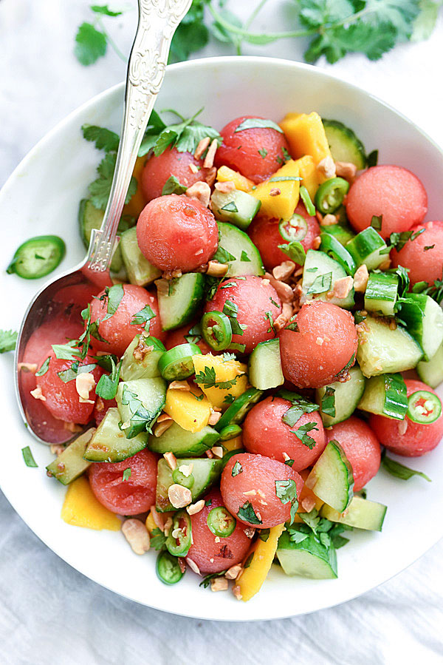
Ingredients
- 1 tablespoon soy sauce (gluten-free if needed)
- 1 small garlic clove, minced
- ½ teaspoon minced ginger
- 2 teaspoons fresh lime juice
- 2 teaspoons rice vinegar
- 3 cups watermelon, deseeded and cut into cubes or melon balls
- 1 English cucumber, chopped into ¼-inch pieces (about 2 cups)
- 1 or 2 peaches, diced (optional to use mango)
- ½ serrano pepper, thinly sliced (optional, creates heat!)
- ¼ cup chopped cilantro
- ¼ cup sliced basil
- ¼ cup salted peanuts, crushed and toasted (optional: sesame seeds for a “nut-free dish).
Instructions
- In a large bowl, whisk together the soy sauce, garlic, ginger, lime juice, and rice vinegar.
- Add the watermelon, cucumber, mango, serrano pepper, cilantro, and basil. Chill for 30 minutes. Drain the excess liquid before serving.
- Serve with the crushed peanuts on top of the salad.

Recipe adapted from Love & Lemons

